MARY JOHNSTON LETELLIER  Dramatic coloratura soprano  Email: maryjohnstonletellier@gmail.com  Phone: (207) 776-4121  Website: www.maryjohnstonletellier.com |  |  |  | 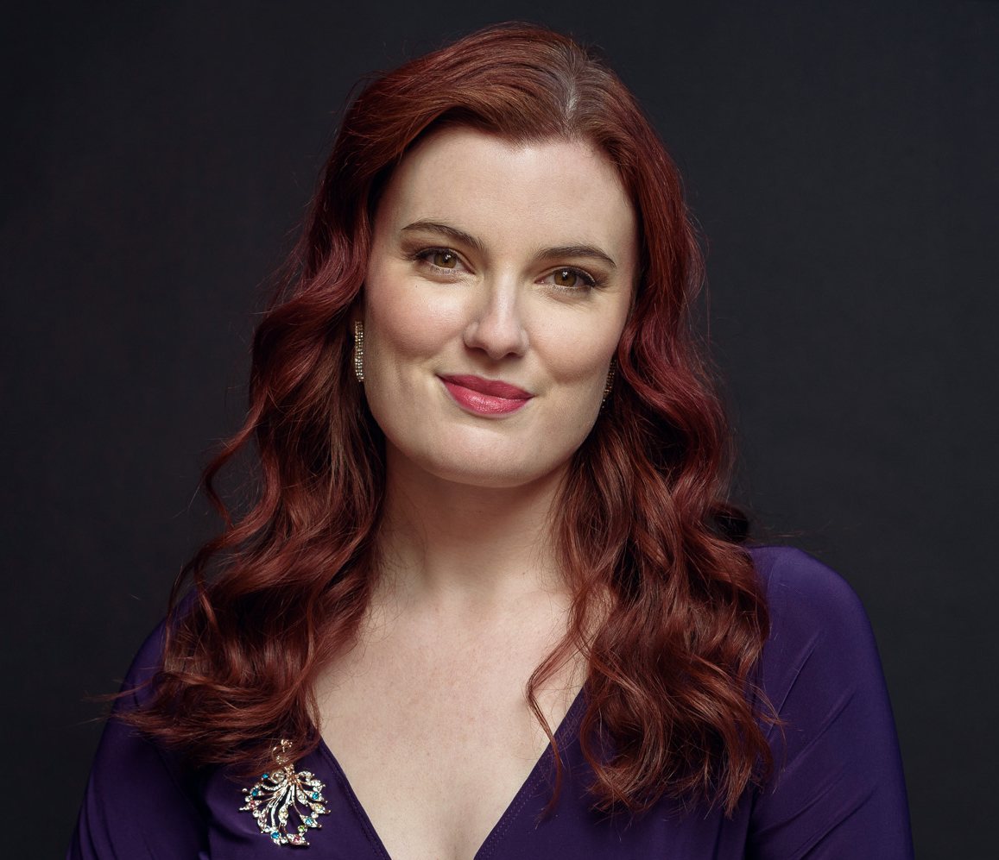
Opera Roles
Amelia | Un Ballo in Maschera |  |  |  |  | Opera in the Pines |  |  |  | 2026
Milica | Svadba |  |  |  |  | Hogfish |  |  |  | 2025
Musetta (cover) | La Bohème |  |  |  |  | Opera Maine |  |  |  | 2025
Harpy | Sarah in the Theater |  |  |  |  | New England Conservatory |  |  |  | 2023
Musetta | Bar Crawl Bohème |  |  |  |  | Opera in the Pines |  |  |  | 2023
Königin der Nacht | Die Zauberflöte |  |  |  |  | New England Conservatory |  |  |  | 2023
Violetta | La Traviata |  |  |  |  | MassOpera |  |  |  | 2021
First Fairy | The Fairy Queen |  |  |  |  | Portland Bach Experience |  |  |  | 2021
First Lady (cover) | Die Zauberflöte |  |  |  |  | Opera Maine |  |  |  | 2019
Norina * | Don Pasquale |  |  |  |  | Portland Conservatory |  |  |  | 2018
Mrs. Ford * | Merry Wives |  |  |  |  | Portland Conservatory |  |  |  | 2018
Violetta | La Traviata |  |  |  |  | Flagstaff in Fidenza |  |  |  | 2013
Peep-Bo | The Mikado |  |  |  |  | The Boston Conservatory |  |  |  | 2011
Mrs. Pinkerton | The Old Maid and the Thief |  |  |  |  | The Boston Conservatory |  |  |  | 2011
The Sandman | Hansel and Gretel |  |  |  |  | The Boston Conservatory |  |  |  | 2011
Magda | La Rondine |  |  |  |  | The Boston Conservatory |  |  |  | 2011
Cunegonde | Candide |  |  |  |  | The Boston Conservatory |  |  |  | 2010
Romilda (cover) | Serse |  |  |  |  | The Boston Conservatory |  |  |  | 2009
Abigail Williams * | The Crucible |  |  |  |  | The Boston Conservatory |  |  |  | 2008
Belinda | Dido and Aeneas |  |  |  |  | The Boston Conservatory |  |  |  | 2008
Tisiphone / Charito | Lysistrata |  |  |  |  | Seagle Music Colony |  |  |  | 2007
Musical Theater Roles
Grace | The Christmas Bride in Concert |  |  |  |  | Snowlion Repertory |  |  |  | 2023
Conrad/Conradine | The Secret Princess (premiere) |  |  |  |  | Snowlion Repertory |  |  |  | 2022
Julie, Carrie, Nettie, Louise | Carousel |  |  |  |  | Tophat Toy Theater |  |  |  | 2019
Franca Naccarelli | The Light in the Piazza |  |  |  |  | City Theater |  |  |  | 2019
Narrator and various roles | Mesmerized (premiere) |  |  |  |  | Snowlion Repertory |  |  |  | 2019
The Ghost of Christmas Past | A Christmas Carol: The Musical |  |  |  |  | City Theater |  |  |  | 2018
* Partial Role
Soloist Work
Our Bodies: Our Voices |  | New England Conservatory |  |  |  |  | 2025
Pining for You |  | Opera in the Pines |  |  |  |  | 2025
East Meets West: Exoticism in Arias and Art Song |  | Opera Maine/ Bowdoin College |  |  |  |  | 2024
Deep Magic from the Earth and Songs to the Moon |  | University of Maine Southern Maine/ New England Conservatory |  |  |  |  | 2024
Handel’s Messiah |  | Messiah Community Chorus |  |  |  |  | 2023
Le Petit Prince: a Musical Journey |  | New England Conservatory |  |  |  |  | 2023
Love Bomb: Domestic Abuse Awareness Concert |  | Solutionary Arts New England |  |  |  |  | 2023
Music on the Patio: Summer Concert Series |  | Sanford Opera |  |  |  |  | 2023
Vaughan Williams’ Dona Nobis Pacem |  | Assabet Valley Mastersingers |  |  |  |  | 2022
Haydn’s The Seasons |  | Assabet Valley Mastersingers |  |  |  |  | 2022
Sing For Their Supper |  | Milton Community Concerts |  |  |  |  | 2022
Try Me, Good King |  | Opera on Tap Maine |  |  |  |  | 2021
MisCast 2021 Soloist |  | Biddeford City Theater |  |  |  |  | 2021
Still Dreaming: A Tribute to MLK |  | Milton Community Concerts |  |  |  |  | 2021
Blue’s Annual Winter Wonderland |  | Port City Blue |  |  |  |  | 2021
317 Main Songs of the Season |  | 317 Main Community Music Center |  |  |  |  | 2020
City Theater Home for the Holidays |  | Biddeford City Theater |  |  |  |  | 2020
Opera Maine Ocean View Recital |  | Opera Maine |  |  |  |  | 2020
City Theater Highlights Concert |  | Biddeford City Theater |  |  |  |  | 2020
BLM: Faculty Concert |  | University of Southern Maine |  |  |  |  | 2020
A Vocal Smorgasbord |  | University of Southern Maine |  |  |  |  | 2019
Broadway at Good Theater |  | Good Theater |  |  |  |  | 2019- 2021
Governor’s Conference on Tourism |  | Opera Maine |  |  |  |  | 2019
SAGE lecture series |  | Opera Maine |  |  |  |  | 2019
Lyric’s Greatest Show Fundraiser |  | Lyric Music Theater |  |  |  |  | 2019
Opera on Tap Maine |  | Opera on Tap Maine |  |  |  |  | 2019 - Present
Marston-Kotzschmar Club |  | Marston-Kotzschmar Club |  |  |  |  | 2019 - Present
Portland Rossini Club |  | Portland Rossini Club |  |  |  |  | 2011 - Present
Professional Ensemble/Opera Chorus
La Bohème |  | Opera Maine |  |  |  |  | 2025
Aida |  | Opera Maine |  |  |  |  | 2024
Der Fliegende Holländer |  | Opera Maine |  |  |  |  | 2021
Die Zauberflöte |  | Opera Maine |  |  |  |  | 2019
Education and Training
Doctorate of Music in Vocal Performance |  |  | New England Conservatory |  |  |  |  |  | Ant: 2026
Complete Vocal Technique 3 Year Diploma |  |  | Complete Vocal Institute |  |  |  |  |  | Ant: 2027
Vocal Pedagogy Professional Workshop |  |  | Boston Conservatory at Berklee |  |  |  |  |  | 2021
Acoustic Vocal Pedagogy (Online workshop - Ian Howell) |  |  | New England Conservatory |  |  |  |  |  | 2021
Opera Programs Berlin |  |  | Online Workshop |  |  |  |  |  | 2020
Flagstaff in Fidenza Opera Program |  |  | Fidenza, Italy |  |  |  |  |  | 2013
Master of Music in Opera Performance |  |  | The Boston Conservatory |  |  |  |  |  | 2011
Bachelor of Music in Vocal Performance: Opera Emphasis |  |  | The Boston Conservatory |  |  |  |  |  | 2009
Seagle Music Colony |  |  | Schroon Lake, NY |  |  |  |  |  | 2006
Awards and Honors
National NATS Artist Award Semi-Finalist/ Anne Marie Gerts Award |  |  |  |  |  |  |  | 2022
New England Regional NATS Artist Award Winner |  |  |  |  |  |  |  | 2021
NATS Maine Chapter President |  |  |  |  |  |  |  | 2021- Present
NATS Maine Chapter Vice President |  |  |  |  |  |  |  | 2019 - 2021
Boston Conservatory Merit Scholarship |  |  |  |  |  |  |  | 2005-2011
Arthur P. Whitney Award for Highest Academic Excellence |  |  |  |  |  |  |  | 2009
Pi Kappa Lambda Membership |  |  |  |  |  |  |  | 2007
Boston Classical NATS (1st Place) |  |  |  |  |  |  |  | 2007
Boston Classical NATS (3rd Place) |  |  |  |  |  |  |  | 2006
Other Information
- Special Skills: Piano, Ballet, Tap, Alexander Technique, Linklater
- Languages: Czech, Italian, French, German, Latin, Spanish
- Voice Teachers: Dana Lynne Varga, Alexandra Dietrich, Lori L’Italien, Ellen Chickering, Dr. Rebecca Folsom, Judith James, Bradley Williamsn Leda Scearce
- Vocal Coaches: Jean Anderson Collier, Michelle Alexander, Libor Dudas, JJ Penna, Rachelle Jonck, Brian Moll, James Myers, Kathleen Scott, Timothy Steele, Michael Strauss, Scott Wheatley
- Directors: Brian Allen, Al D’Andrea, Kirsten Z. Cairns, Ben Evett, Katy Early, David Gately, Joshua Major, Nando Schellen, Greg Smucker, Sally Stunkel, Linda Sturdivant, Dona D. Vaughn
- Conductors: Beatrice Afron, Nell Britton, Darko Butorac, Robert Eaton, Israel Gursky, Bruce Hangen, Keith Howard, Roberto Kalb, Eckert Preu, Dan Ryan, Tim Verville, Jan Schweiger, Sara Sturdivant, Bob Tweten

